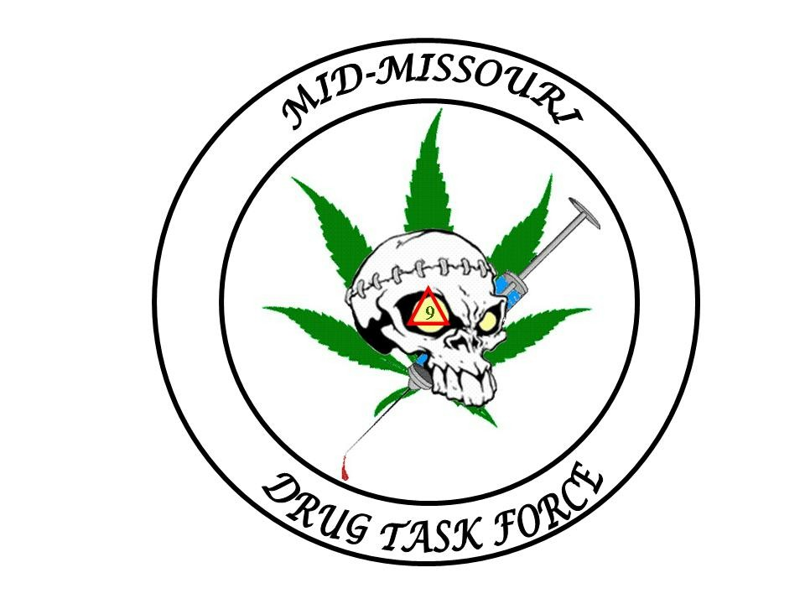
Mid-Missouri Multi-Jurisdictional
Drug Task Force
BOARD OF DIRECTORS

Director:
Sheriff Jim Petty

Vice President:
Sheriff Bill Abbott

Secretary/Treasurer:
Sheriff Kevin Bond

Director Of UnderCover:

BOARD MEMBERS

Sheriff Charlie Polson

Sheriff Jerry Wolfe

Sheriff Jay Gump

Sheriff Rick Fajen

Chief Shane Edwards

Chief Mark Maples

Chief Stormy Walker

Chief Jason Atwood

Chief Jim Ulm

M.M.M.J.D.T.F.

211 East Newton Street
Versailles, Mo. 65084

OFFICE- (573) 378-5481
FAX- (573) 378-7171

Email- midmodtf@yahoo.com

October 7th, 2011

Press Release

In a joint investigation with the California Police Department, the Mid-Missouri Drug Task Force is making the following information available;

On the evening of October 4th of 2011 officers of the Mid-Missouri Drug Task Force and the California Police Department seized an active Methamphetamine lab from apartment number C-13 at 1305 West Buchanan Street in the city of California. Officers had received information prior to the seizure that Jacob Murphy was manufacturing Methamphetamine in the apartment.

Officers seized Coleman Fuel, Denatured Alcohol, Sulfuric Acid, Lithium, Lye and Ammonium Nitrate from the apartment. Also seized were digital scales, packaging material, Methamphetamine and two active Hydrochloride gas generators.

Arrested at the scene was Jacob Murphy, age 28 of California, Dale Bosley, age 28 of California and Michelle McMillin, age 37 of California. A child was also located in the residence and turned over to the Division of Family Services for treatment and evaluation.

Jacob Murphy, Dale Bosley and Michelle McMillin were charged with the class a felonies of Manufacture of a Controlled Substance Within 2000 Feet of a School and Manufacture of a Controlled Substance With a Child In The Residence and the class C felony of Possession of a Controlled Substance.

All three suspects are being held at the Moniteau County Jail. The suspects are being held without bond.

End of Release

