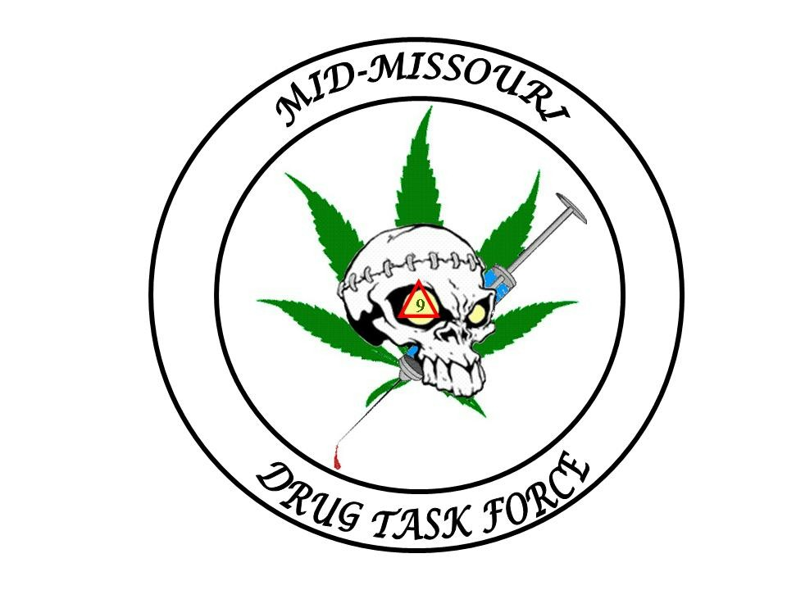
Mid-Missouri Multi-Jurisdictional
Drug Task Force
BOARD OF DIRECTORS

Director:
Sheriff Jim Petty

Vice President:
Sheriff Bill Abbott

Secretary/Treasurer:
Sheriff Kevin Bond

Director Of UnderCover:

BOARD MEMBERS

Sheriff Charlie Polson

Sheriff Jerry Wolfe

Sheriff Jay Gump

Sheriff Rick Fajen

Chief Jesse Calvin

Chief Mark Maples

M.M.M.J.D.T.F.

211 East Newton Street
Versailles, Mo. 65084

OFFICE- (573) 378-5423
FAX- (573) 378-7171

Email- midmodtf@yahoo.com

PRESS RELEASE

On the afternoon of June 30th of 2009 officers of the Mid-Missouri Drug Task Force and the Morgan County Sheriff’s Office went to the residence located at 200 South Van Buren Street in the City of Versailles. The officers were investigating an anonymous report that one of the residents, James Dornan III, age 39, was in possession of Methamphetamine.

During this investigation officers made contact with James Dornan III and subsequently removed an active Methamphetamine lab from the basement of the residence. Also recovered were digital scales, powder Methamphetamine and over 100 grams of liquid Methamphetamine.

James Dornan III was arrested at the scene. During an interview he confessed to manufacturing Methamphetamine in the basement of his residence for the last year.

James Dornon III was charged with Manufacture of a Controlled Substance, a class B felony, and is being held on a $50,000.00 cash only bond at the Morgan County Jail. He is also being held without bond for violation of his probation on a similar incident that occurred at the same residence in the fall of 2004.

The investigation in ongoing and other arrests are imminent.

Lt. J.D. Williams
Mid-MO DTF

Serving Benton, Cooper, Howard, Miller, Moniteau, Morgan and Pettis counties

