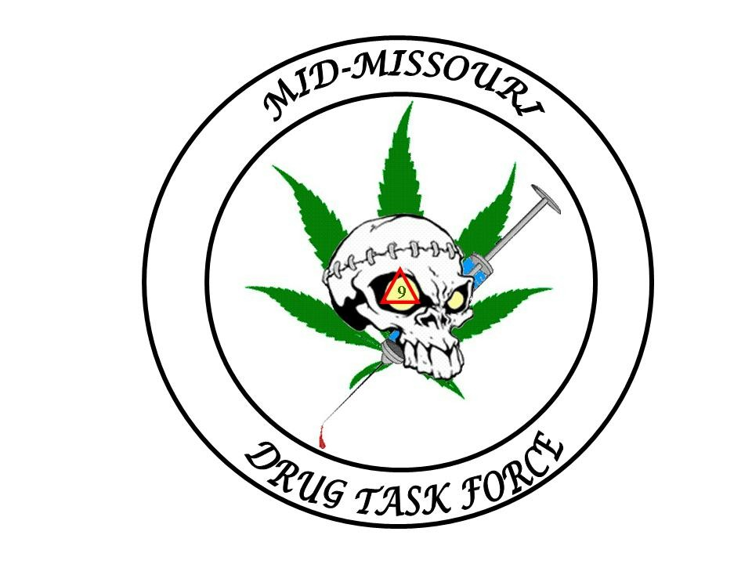
Mid-Missouri Multi-Jurisdictional
Drug Task Force
BOARD OF DIRECTORS

Director:
Sheriff Jim Petty

Vice President:
Sheriff Bill Abbott

Secretary/Treasurer:
Sheriff Kevin Bond

Director Of Under Cover:

BOARD MEMBERS

Sheriff Charlie Polson

Sheriff Jerry Wolfe

Sheriff Jay Gump

Sheriff Rick Fajen

Chief Jesse Calvin

Chief Mark Maples

M.M.M.J.D.T.F.

211 East Newton Street
Versailles, Mo. 65084

OFFICE- (573) 378-5423
FAX- (573) 378-7171

Email- midmodtf@yahoo.com

PRESS RELEASE

The Mid-Missouri Drug Task Force is making the following release;

On the evening of July 13th, 2009 in a joint investigation with the Moniteau County Sheriff’s Office, the Morgan County Sheriff’s Office, the California Police Department, the Versailles Police Department and the Missouri State Highway Patrol, a search warrant was executed at 303 South High Street in the City of California.

Found at the scene were three marijuana plants, marijuana, cocaine, three sets of digital scales, packaging material, a stolen pistol and approximately $5,000.00 in cash. At the time the warrant was served approximately 11 people were found in the residence.

Two Hispanic males and one Hispanic female were arrested at the scene. Maria Vargas, age 43, was charged with Production of Marijuana, a class B felony. Jonathan Lopez-Lopez, age 21 and Jose Aguilar, age 19 were charged with Possession of Cocaine, a class C felony. All three suspects are being held without bond at the Morgan County Jail.

The investigation is continuing and additional arrests will be forthcoming.

Lt. J.D. Williams
Mid-Missouri Drug Task Force

Serving Benton, Cooper, Howard, Miller, Moniteau, Morgan and Pettis counties

